Houston Independent School District

8330 Triola LN.
Houston, TX 77036

Office (713) 458-5555 Fax (713) 458-5567

http://schools.houstonisd.org/Liberty
Mr. Monico Rivas, Principal


Student Handbook

Welcome - bienvenidos

Welcome to Liberty High School! We are pleased to have you as a member of our student body as you work to complete the requirements for a high school diploma.

Principal’s Welcome

Students,

Welcome to Liberty High School! You have made an important decision to continue with your education and to prepare yourself to positively impact your future, and your community.

In many ways, your experience as a student here at Liberty will be like many of the experiences in life that define our present and our future in our own daily lives outside of school. As a student, there will be times when you will be excited about learning a new concept or new skill and there will be times when you will be filled with frustration as you wrestle with understanding an illusive part of your lessons. There will be times when you will feel proud that you attended all of your classes despite feeling tired from many hours of work or despite a family need that also requires your attention. On other days, you will find comfort in seeing classmates who are experiencing similar circumstances in their lives and who are being successful in their educational endeavors.

There are numerous reasons why students have chosen to enroll at Liberty High School; however, the end goal for all students at Liberty is to arrive at the same destination: to earn a high school diploma and continue to open a universe of possibilities for a better future.

The faculty and staff in our school is glad to have the opportunity to work with you and to be part of your life as you work to earn a high school diploma. The teachers, office staff, and administrators at Liberty High School are committed to helping you succeed! By communicating any questions, needs or concerns to your teachers, tutors, or the office staff, and by working hard while never giving up, you will be well on your way to reaching your goal.

Sincerely,

Mr. Rivas
Principal

Academic Program
Students must earn at least 26 credits to earn a high school diploma. Throughout your course of study at Liberty, you will take classes in a variety of academic disciplines to provide a well-balanced education. The areas of study will include:

- English
- Science
- Social Studies
- Mathematics
- Computer Technology
- Fine Arts
- Physical Education
- Foreign-Language and
- Other Elective Classes.

In addition to taking required classes, the study of the English language is an important part of each course at Liberty High School. While you learn each subject, you will also strengthen your skills in writing, reading, speaking and listening. By working closely with your teachers and by practicing what you learn, you will be able to reach your academic goals!

Contact information
Please be sure to keep your personal contact information updated. This includes your phone number, address, and emergency contact. If you have information that needs to be updated, please see Ms. Esparza or the front office.

Credit Evaluation
If you took high school courses in your home country, it is recommended that you submit your school transcript, report card or other documents that verify the courses you took. These documents will be reviewed and will be used to determine if you will receive credit for such courses. Please see Ms. Esparza for more information.

Attendance/Truancy
Attendance to each of your classes is required. To ensure that you have the best opportunity to learn and to earn credits for each of your classes, it is important that you attend classes on each of the assigned days.

● An automatic phone call will go out for every unexcused absence during the instructional day.
● Three unexcused absences – student will receive a phone call and warning letter from truancy officer and/or home visit.
● Ten or more excused/unexcused absences – student will not receive credit for their courses and student will be referred to truancy court (under 19 years of age).

If you must be absent, be sure to fill out a form to excuse your absence. Forms to excuse absences may be picked up from the front desk. Completed forms should be placed in the box located on the reception counter.

Follow the guidelines listed below when turning in an excused note:
a) Include your first and last name
b) Student number
c) Date you were absent
d) Reason for absence
e) Telephone number to verify the absence

Once you have written your excuse note it must be turned in to the main office where it will be stamped with the date it was submitted. You have a maximum of two days after you have returned to school to submit your form.

Students can appeal for classes at the end of the semester if the following criterion has been met:
- Attendance has improved from the previous semester
- You have a minimum of 70 % average for the class
- Commit to making up academic time or the assigned community service hours.

COURSE CREDIT APPEALS POLICY

Final Grade is > 85 | Appeal Granted
5-10 absences and grade is 75-84 | Assigned ½ hour make-up academic time per class period absence. If student completes requirement, appeal is granted.
More than 10 absences and grade is 70-74 | Assigned 1 hour make-up academic time per class period absence. If student completes the appeal requirement, the appeal is granted.

When the Appeals Committee meets with students it will consider the following:

- Number of absences (e.g. 6 v 26)
- Excused or unexcused status
- Course grade
- Pattern of absences (e.g. every Friday, 6th period only, etc)
- History of Prior appeals
- Evidence of improvement
- Reason for absences

Late arrival to school and tardy to class
All students are required to arrive to school on time and be on time for each class. Students who arrive to school past 15 minutes of the first period will be required to stay after school to make-up the time. Students who arrive late to school will be given a detention by the school administrative team. Students who are tardy to class during passing periods will be given a consequence based on the teacher tardy policy.

Consequences for not attending required Academic Make-up time:
- Phone conference with parent/guardian
- Student conference with teacher/counselor/parent, and/or administrator
- Saturday Community Service hours
- In School Suspension
- Out of School Suspension

Code of Conduct
All students are to familiarize themselves with the HISD Student Code of Conduct. The Code of Conduct Handbook is available in the reception area for all students. School rules are in effect not only in the school but also during field trips and other school sponsored events. Failure to follow the rules of the school and school district will result in disciplinary action.

Dress code Policy-School Uniform
Polo shirts for both boys and girls (royal blue, white, gray with school logo)
Pants: solid blue jeans and khaki pants
Shorts: jean or khaki (two inches above knee)
Shoes: closed shoes for both boys and girls

Caps, hats, or “dew” rags are not to be worn in the classroom. T-shirts, shirts, or jewelry that depicts gang/cult affiliation are not allowed in school. Pants are to be worn at the waist. Skirts and dresses are to be no more than two inches from the knee.

Cell Phones
Cell phones may not be used in the classroom. Cell phones are to be turned off while you are in class. Phones can be used during break time. In case of an emergency, family members must call the main office at 713-458-5555 and the student will be notified.
I-Pods/IPads and other electronic audio devices are not allowed in class unless the instructor has approved the use for instructional purposes.

Faculty and staff members will confiscate electronic devices if they ring, are displayed, or are used. The first confiscation will result in a warning and the student will be required to sign a contract. The second and future confiscations will include a $15 fine payable, after school each day, to Ms. Marcia (AM) or (PM). Electronic devices of minor students must be picked up by a guardian.

STAFF WILL NOT BE RESPONSIBLE FOR LOST ELECTRONIC DEVICES, INCLUDING CELL PHONES THAT HAVE BEEN CONFISCATED DUE TO FAILURE TO COMPLY WITH CELL PHONE POLICY.

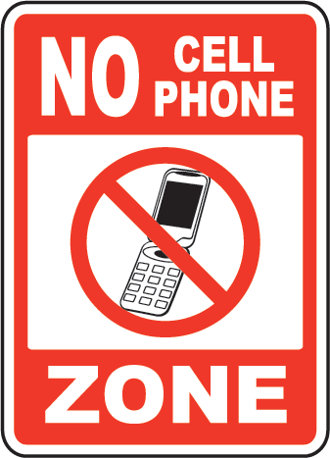

Leaving Campus without permission
Students may not leave campus without permission from a school administrator. Going to stores or restaurants between classes or during dinner time is not permitted and will result in a disciplinary consequence.

Consequences for students leaving campus without permission during class or during dinner/lunch time:

First Offense: Warning by teacher, campus officer or administration
Second Offense: Conference with parent/guardian and academic make-up time required
Third Offense: Office referral – Saturday Community Service hours assigned

Parking
Student parking is available in front of the school. Students should always keep this area clean and safe. Students may not sit inside their cars during dinner or break time.

Students sitting inside their cars before/after class and during dinner time:

First Offense: Warning by teacher, campus officer or administration
Second Offense: Conference with parent/guardian
Third Offense: Office referral – lunch/dinner detention
Fourth Offense: Office referral – In School Suspension

Unsafe driving in parking lot:
First Offense: Warning by teacher, campus police officer or administration (note: if the driving violation is warrants intensive intervention from the police officer, a ticket or arrest can occur on the first violation)
Second Offense: Office referral. Student will be assigned community service hours.
Third Offense: Office referral. Conference and Suspension from school.
Fourth Offense: Office referral. Conference with student and possible ticket from police officer.

EMERGENCY PROCEDURES
Students will adhere to all procedures relevant to emergencies.
- Your classroom teacher will have instructions for you to follow in case of fire or any other emergency.

- Listen for announcements and instructions communicate through the public announcement system.
- Your safety and the safety of others depends on how well you follow directions.
- Remember: your teacher is there to assist you.

Student ID’s
All students are issued an ID. ID’s must be worn at all times while on campus or when participating in school sponsored events. If a student does not bring his/her ID he/she will be charged $1.00 for a temporary ID.

If an ID is lost there will be a $5.00 fee for a replacement.

Computer Usage
The students are responsible for appropriate behavior on the school’s computer network just as they are in a classroom. It is expected that users will comply with district standards as follows:

- Privacy - Network administrators may review communications to maintain system integrity.

- Storage capacity – Users are expected to remain within allocated storage and delete materials which take up excessive storage.

- Illegal copying – Students must never download or install any commercial software, shareware, or freeware onto network drives, or USBs’, unless they have written permission from the network administrator. Students must not copy or open other students’ files.

- Inappropriate materials or language – Profane, abusive, or impolite language should not be used to communicate, nor should materials be accessed which are not in line with the rules of school behavior.

Consequence(s) for violation of technology/laptop use:
Classroom teacher will confiscate laptop and submit discipline report to the school administrator.
The school administrator will have a conference with student and parent/guardian.
Depending of the severity of laptop violation, the student may be required to complete community service hours, have in school suspension or out of school suspension.
If the student had damaged the laptop and it must be confiscated, the student will still be responsible for the completion of all school work.

Advocacy and Student Support Services
All students are enrolled in advocacy class where there are opportunities to discuss topics such as academic progress, personal development, information about family and social services, and to develop interpersonal skills

Personal Development and Personal Relationships
The ability to balance life between employment, school, family, and personal responsibilities, without neglecting your basic needs, will permit you to stay on course toward accomplishing your goals. It is important to communicate your educational goals and plans to your family, friends and employers so that you may receive as much support as possible. The support that your family can provide you is very important. Also, it is helpful to establish a good relationship with your employers so that they may also be able to help you reach your educational goals.

Tutorials
To ensure that you have every opportunity to be successful in your coursework, tutorials are available Monday through Saturday. Tutorial services are available for students who need help with completing assignments or who want additional skill practice. Students may request tutorial support from their teachers on a as needed basis. For additional information about tutorials, please speak with your teachers.

College Success Program- Naomi Brito
Naomi Brito works with our seniors to provide a high-quality comprehensive advising program to all students and families, empowering students to pursue and attain a college degree. Ms. Brito advises students to develop a college-bound mindset and assist students through the college admission process. Ms. Brito also supports students with obtaining grants, scholarships, and other forms of aid to increase affordability. Ms. Brito is available every Wednesday and Thursday of the week, from 7:30 to 4:30pm.

School Counselor – Sally Lawlace
Works with students regarding academic, social and personal challenges. Makes referrals for resources related to counseling, health care or family issues. Meets with parents and students to select an endorsement pathway for their PGP. Creates the master schedule and student schedules. Ms. Lawlace also meets with students to discuss individual review of credits and post-secondary goals.

Withdrawal from school
If for any reason you must withdraw from school, you are required to inform the registrar (Ms. Esparza) and Mr. Rivas or assistant principal, of your intent to withdraw from school. It is very important that you communicate with us about options to complete your education. You can also call 713-458-5555 so that we may speak about any concerns that you may have.

Faculty and Staff
Title | Position | Location
Rivas, Monico | Principal | Main Office
Molina, Camelia | Assistant Principal- AM | Workroom
Ibao, Mario | Assistant Principal-PM | Registrar Office
Lawlace, Sally | Counselor | Workroom
Oprea, Cornelia | Literacy Coach | Workroom
Abarca, Jessica | School Secretary | Main Office
Bair, Brian | Police Officer | Workroom
Reyna, Joe | IT Support | Registrar Office
Esparza, Nayebe | SIMS Clerk | Registrar Office
Marcia, Keidy | Front Desk Receptionist-AM | Main Office
Villanueva, Carmen | Front Desk Receptionist-PM | Main Office
Vacancy | Graduation Support Specialist | Registrar Office
Manyana, Abraham | School Nurse | Registrar Office
McGowan, Eileen | Wrap-Around Specialist | Workroom
Gebremikael, Yirgalem | Academic Tutor
Salim, Nasir | Academic Tutor
Getahun, Abdi | Academic Tutor
Lorz, Alicia | Academic Tutor
Tekie, Makda | Academic Tutor
Yabanci, Luay | Academic Tutor
Hayes, Malkia W. AM | LEAD – ESL/ELA | 101
Fraga, Tonya J. AM | ESL Teacher | 103
Petersen, Carol PM | ESL Teacher | 103
Wycough, Jeanine PM | ESL Teacher | 102
Watkins, Christine M. AM | ESL Teacher RM102 | 102
Klein II, John M. AM/PM | LEAD CATE/ESL Teacher RM105 | 109
Hernandez, Rigo AM/PM | Physical Education
Kwan, ShunPing AM | Art | 107
Aguiluz, Katerin AM | Virtual Lab Facilitator | 108
Reyes, Verenice PM | Virtual Lab Facilitator | 108
Cortez, Gloria AM | CTE | 109
Holloway, Justin C. | Speech Communication
James, Eddison AM | Math Teacher | 105
Sandhe, Priyang AM | Math Teacher | 110
Munoz, Diana PM | Math Teacher | 105
Sainz Ramirez, Miguel AM | Science Teacher | 104
Melton, Arvin PM | Science Teacher | 104
Blessinger Ann E. PM | Social Studies Teacher | 106
Borow, Randall A. AM | Social Studies Teacher | 106
Elegarle, Ricardo | SCIENCE
Jack, Janine | CTE
Dua, Agyeman | ART
Carrillo, Mario | MATH
Burnias, Sergio AM | Dedicated Associate Teacher
Vacancy PM | Dedicated Associate Teacher
Su, Sandra | ELA Support
Gonzalez, Anayibi | Plant Operator
Reina, Ramon | Custodian
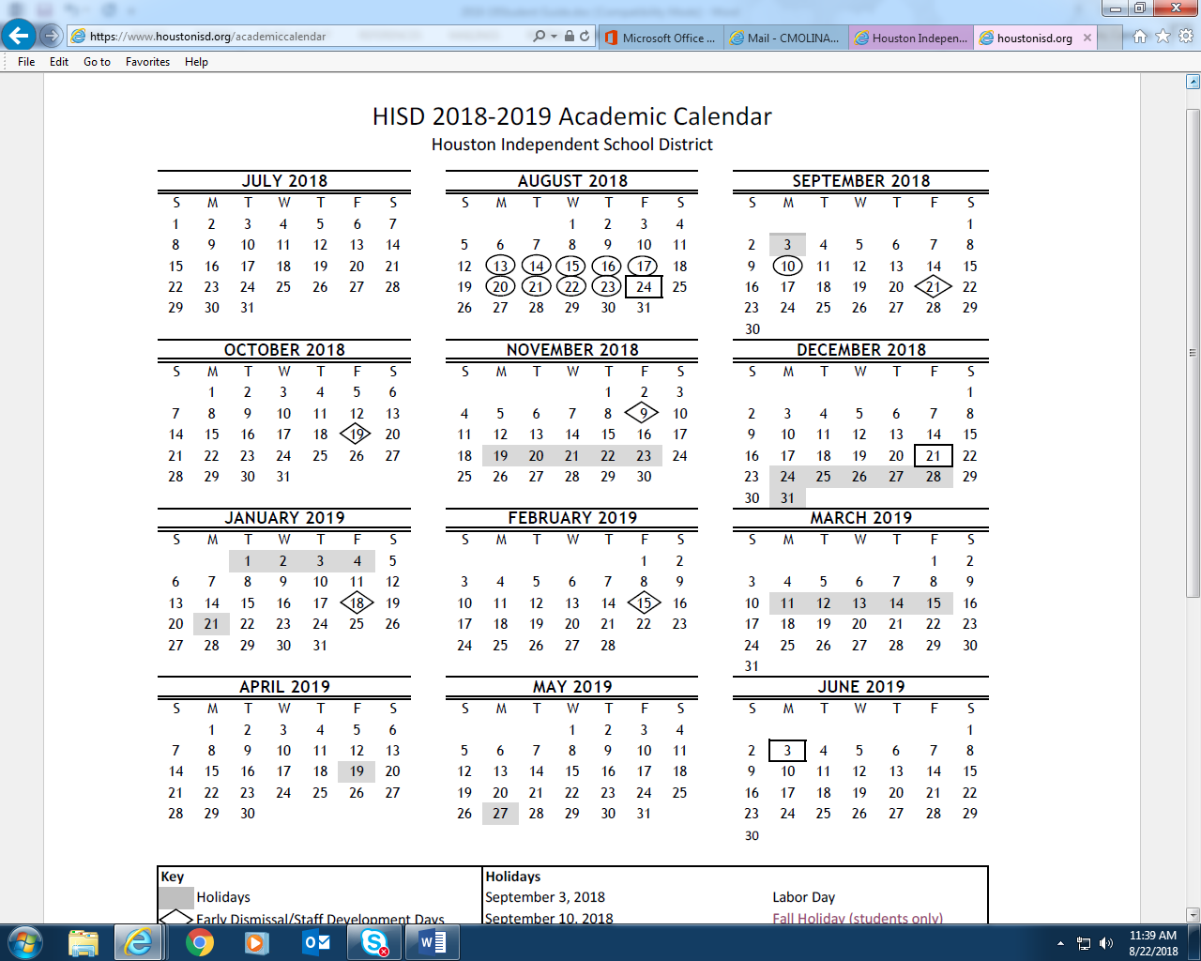

STAAR Testing Dates
December 3 – 7 of 2018

TELPAS Testing Dates
Feb. 25 – April 5 of 2019

STAAR Eng I and Eng II
April 9 and April 10 2019

STAAR Testing Dates
May 6-10 of 2019
Holidays
September 3, 2018
September 10, 2018
November 19-23, 2018
December 24 – January 4, 2019
January 21, 2018
March 11-15, 2018
April 19, 2019
May 27, 2019

Liberty High School



Excuse Absence Form

Date:

Student’s Name (complete name):

Student’s ID:

Date of Absence/s:

Reason for your Absence:

Parent/Student Signature:

Phone Number/Cell phone Number

Please attach any necessary documents….

*You have a maximum of two days after you have returned to school to submit your form*

Liberty High School

Formulario Para Justificar Ausencias

Fecha:
Nombre del Estudiante: (completo y letra de molde:
Número de Identificación Estudiantil:

Fecha(s) de la(s) ausencias:

Razón por haber estado ausente:

Firma del padre o estudiante:

Número de Teléfono/Número de Teléfono Celular:

Por Favor adjuntar documentos necesarios….

*Tiene máximo dos días para entregar esta forma después de su regreso a la escuela*

